|  |  |
| --- | --- |
|  |  |

# Drink Vending Machine

# Group/Team: 19

# AC51003: Software Engineering

TABLE OF CONTENTS

USE CASE DIAGRAM 3

STRIDE ANALYSIS 4

UC1 Buy Drink 5

Basic Flow of Events 5

Alternative Flows 5

A1 – Low credit, go to Top Up 5

Exception Flows 5

E1 – Invalid pin 5

UC2 Top Up 6

Basic Flow of Events 6

Exception Flows 6

E1 – Invalid pin 6

E2 – bank details authentication failed 6

UC3 Dispense water 7

Basic Flow of Events 7

Alternative Flows 7

A1 – Take free water from the machine 7

Exception Flows 7

E1 – No water from the main water supply 7

UC4 Login 7

Basic Flow of Events 7

Exception Flows 8

E1 – Invalid pin 8

UC5 Refill 8

Basic Flow of Events 8

Exception Flows 8

E1 – Invalid pin 8

UC6 Update Records 9

Basic Flow of Events 9

Exception Flows 9

E1 – Invalid pin 9

UC7 Repairs 9

Basic Flow of Events 9

Exception Flows 9

E1 – Invalid pin 9

UC8 Stock / Fault Report 10

Basic Flow of Events 10

Alternative Flows 10

A1 – Fault part or none responsive part 10

UC9 System Update 11

Basic Flow of Events 11

UC10 Service Report 11

Basic Flow of Events 11

UC11 Verify Pin 11

Basic Flow of Events 11

Exception Flows 11

E1 – Wrong pin 12

USE CASE DIAGRAM: Drink Vending Machine

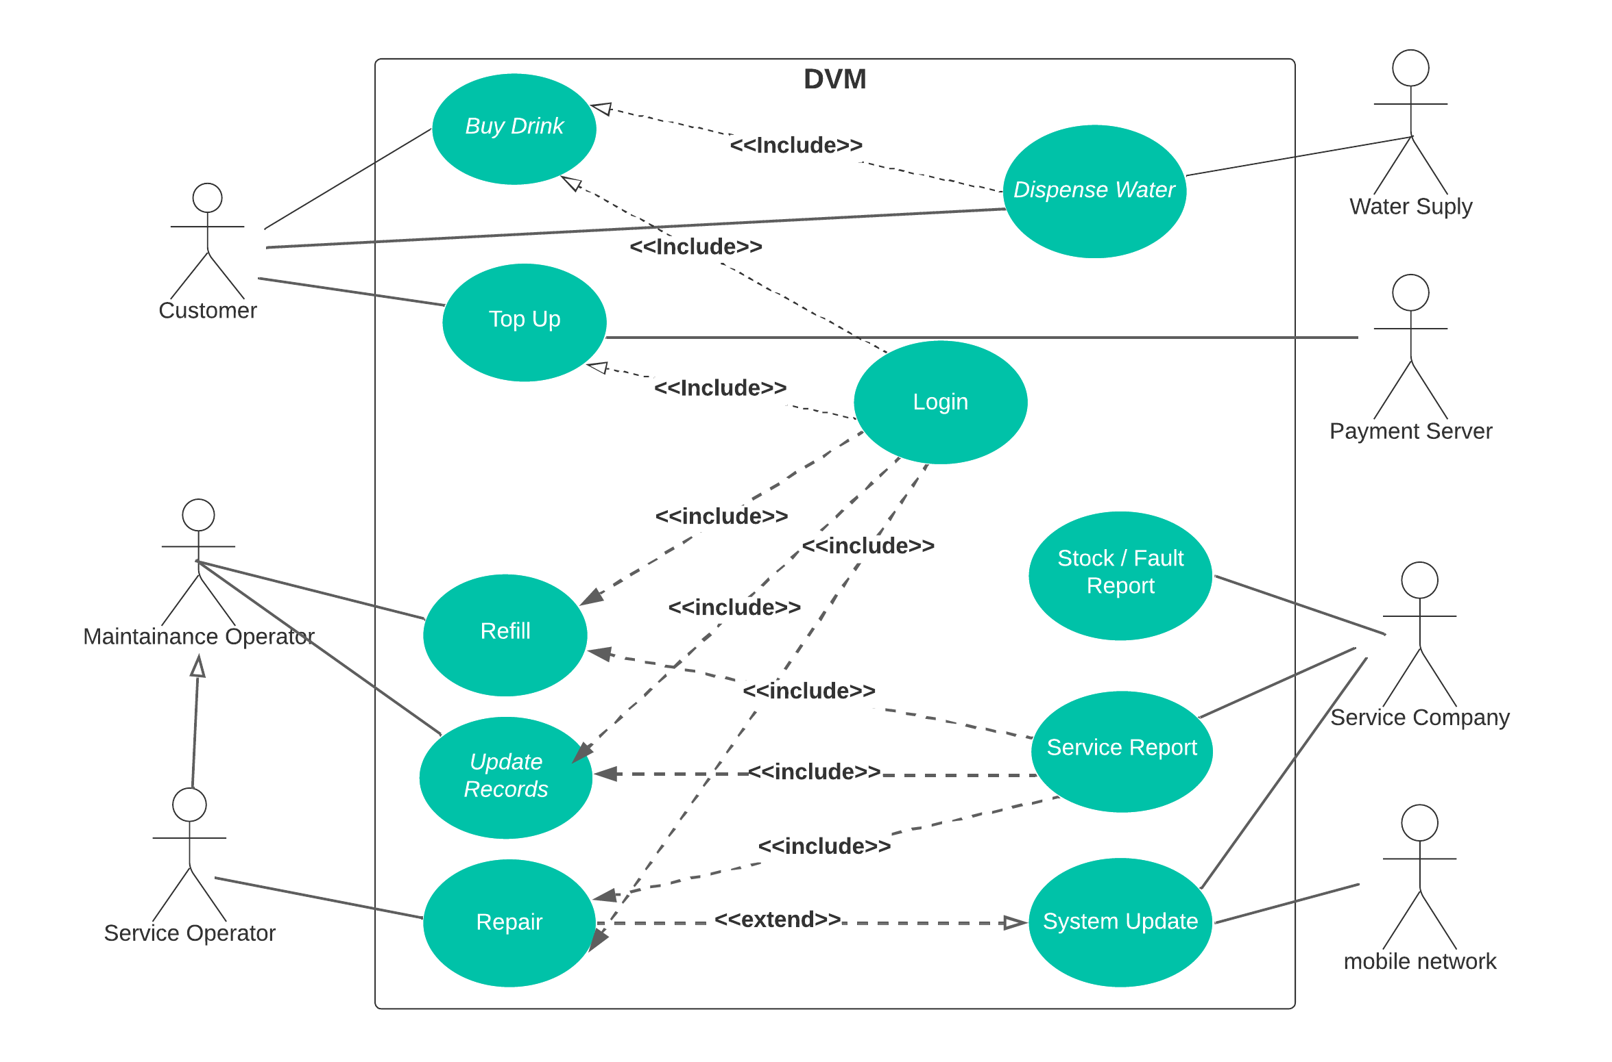

STRIDE ANALYSIS

**Spoofing**: The vending machine could be vulnerable to spoofing attacks, where an attacker impersonates a legitimate user or vending machine service operator or maintenance operator to gain unauthorized access to the machine or to steal drinks.

**Tampering**: The vending machine could also be vulnerable to tampering, where an attacker physically alters the machine to gain unauthorized access or to steal drinks. For example, an attacker could try to break into the machine to steal the drink or damage the card reader slot to make it easier to steal drinks.

**Repudiation**: There is a risk that a user could repudiate a transaction or deny that they made a purchase from the vending machine. For example, a user could claim that the machine did not dispense the correct drink.

**Information Disclosure:** The vending machine could be vulnerable to information disclosure attacks, where an attacker could gain access to sensitive information such as the inventory levels or sales data. For example, an attacker could use a network scanner to intercept and steal sensitive data being transmitted between the machine and the central server.

**Denial of Service:** A denial of service attack could be launched against the vending machine, either by physically damaging the machine or by flooding the machine with requests in an attempt to overload it and prevent legitimate users from accessing it.

**Elevation of Privilege:** There is a risk that an attacker could elevate their privileges on the vending machine to gain unauthorized access or control. For example, an attacker could exploit a vulnerability in the software running on the machine to gain service operator or maintenance access and modify the inventory or card top up settings.

UC1: BUY DRINK

This use case is initiated by the customer. It allows customers to purchase drinks from the vending machine.

Basic Flow of Events

|  |  |
| --- | --- |
| Customer: | The use case begins when the customer wants to buy drink and insert their vending card |
| System: | Machine read the card. (**E1: Invalid pin**) |
| System: | The system displays the amount of credit available in the customer’s vending card |
| System: | The system displays the list of drinks available and affordable according to the balance in the inserted vending card. |
| Customer: | The customer sees available balance list of available drinks he can purchase |
| Customer: | Then customer choose their desirable drink (**A1: Low credit, go to top-up** ) |
| System: | The system ask the customer the desired temperature for their chosen drink cold or hot |
| Customer: | The customer chooses their desired temperature for the drink. |
| System: | The system dispenses the correct cup from the chute containing the powdered drink and also the water with the chosen temperature. |
| Customer: | The customer takes the dispensed drink. |
| System: | The system deducts the drink price from the vending card. |
| System: | The system returns to the starting screen and display the remaining balance of the customer’s vending card. |
| Customer: | The customer choose to buy more or ends the transaction and eject their card. |
| System: | The system returns to a ready screen for another customer. |

Alternative Flows

A1 – Low credit, go to top-up

|  |  |
| --- | --- |
| System: | Display low credit and ask the customer to top Up. |
| Customer: | The customer confirms to go to top-up their account. |
| System: | The system redirects the customer to a top-up screen. |
| Customer: | The customer proceeds to top up the vending card. Details in **UC2** |

Exception Flow

E1 – Invalid pin

|  |  |
| --- | --- |
| System: | The system displays error message of “Invalid pin or wrong card” |
| System: | The system prompts the customer to enter the correct pin |
| Customer: | The customer enter the correct pin. |
| System: | The system approves the pin and display the balance and the available drink affordable to customer depending on the amount of credit left. |

UC2: TOP UP

This use case is initiated by the customer. It allows customers to top-up their vending card when their balance is low.

Basic Flow of Events

|  |  |
| --- | --- |
| Customer: | The customer initiate the use case by inserting their vending card into the machine. |
| Customer: | The customer enters their pin (**E1: invalid pin**) |
| System: | The system will display a top-up option on the screen with their balance alongside. |
| Customer: | The customer chooses the top up option. |
| System: | The system display input fields for the customer to enter their bank details |
| Customer: | The customer enters their bank credit card number, expiry date, CVC code and amount not more than |
| System : | The system sends the customers bank details to the payment server for verification and processing. |
| Payment server : | The payment server process the request and complete the transaction by toping up the customer’s vending card with £30 maximum. (**E2: Bank details Authentication failed**) |
| System : | The system then displays a successful top up to the customer’s account. |
| Customer: | The customer proceed with buying drink or remove the vending card. |

Exception Flow

E1 – Invalid pin

|  |  |
| --- | --- |
| System: | The system displays error message of “Invalid pin or wrong card” |
| System: | The system prompts the customer to enter the correct pin |
| Customer: | The customer enters the correct pin. |
| System: | The system approves the pin and display the balance and allow to customer to proceed with the top-up. |

E2 – Bank details Authentication failed

|  |  |
| --- | --- |
| Payment server: | The payment server send error message to the vending machine. |
| System: | The system displays the error message to the customer. |
| Customer: | The customer enters the correct bank details. |
| System : | The system sends the customers bank details to the payment server for verification again |
| Payment server: | Approves the transaction and sends success message to the system |
| System: | The system displays the success message to the customer |

UC3: Dispense Water

This use case is initiated by the customer when buying drink or when taking free hot or cold water. It is an extension of buy drink uses case which must be executed before purchase of drink will be successful.

Basic Flow of Events

|  |  |
| --- | --- |
| Main water supply : | The main water supply supplies water to the vending machine. (**E1: No water from main water supply**) |
| System : | Half of the water will be heated by the system, leaving the other half cold. |
| Customer: | The customer chooses to buy drink (**A1: Take Free Water**) |
| System: | The system display option of either cold or hot after selecting an available drink |
| Customer: | The customer select his desired option. |
| system : | The system dispenses the water as selected in the cup containing drink powder. |

Alternative Flows

A1 – Take free water from the machine

|  |  |
| --- | --- |
| Customer: | The customer chooses to take free water from the vending machine. |
| System: | The system display option of either cold or hot water. |
| Customer: | The customer makes choice of the right temperature |
| System: | The system dispenses the water as selected by the customer. |

Exception Flows

E1 – No water from the main water supply

|  |  |
| --- | --- |
| Main water supply: | The main water supply failed to supply water to the vending machine. |
| System: | The system would halt the purchase of drink and free water dispensing. |
| System: | The system displays the message to the customer of unavailability of water from the main water supply. |
| Customer: | The customer will be left with only top-up option. |

UC4: Login

This use case can be initiated by the three primary actors of the system: Customer, maintenance operator and service operator. It is a prerequisite to access the system.

Basic Flow of Events

|  |  |
| --- | --- |
| Customer: | The customer inserts his vending card into the card reader of the machine. |
| System: | The system read the card and prompt the customer to enter pin. |
| Customer: | The customer enters their pin. |
| System: | The system verifies the provided pin. **E1: Invalid pin** |
| Customer: | The customer gets access to buy drink or to top-up their card. |

Exception Flow

E1 – Invalid pin

|  |  |
| --- | --- |
| System: | The system displays error message of “Invalid pin or wrong card” |
| Customer: | The customer will not get access to the system for purchase or top-up. |
| System: | The system prompts the customer to enter the correct pin |
| Customer: | The customer enters the correct pin. |

UC5: Refill

This use case is initiated by the maintenance operator or the service operator to refill the machine with stock.

Basic Flow of Events

|  |  |
| --- | --- |
| Maintenance Operator | The use case is initialized by the maintenance operator after inserting a special card into the machine. |
| System | The system read the special card inserted by the maintenance operator. |
| Maintenance operator | The maintainer enters the authorization pin to login. |
| System | The system checks the pin for authorization (**E1: Invalid Pin)** |
| System | The system also accesses the operational level of the special card inserted to make sure it has access level one (1) and unlock the door of the vending machine. |
| Maintenance Operator | The Maintenance Operator get access to the interior of the vending machine. |
| Maintenance Operator | Check available stock and refill stock |
| Maintenance Operator | Clean the machine |

Exception Flow

E1: Invalid pin

|  |  |
| --- | --- |
| System | The pin is invalid |
| System | The system will not give access to the maintainer |
| System | The system will prompt the operator to re-enter pin. |
| The maintainer | The maintainer tries to login again with correct pin. |

UC6: Update Records

This use case is initiated by the maintenance operator conducting maintenance of the drinks vending machine.

Basic Flow of Events

|  |  |
| --- | --- |
| Maintenance Operator | The use case is initialized by the maintenance operator after inserting a special card into the machine. |
| System | The system read the special card inserted by the maintenance operator. |
| Maintenance operator | The maintainer enters the authorization pin to login. |
| System | The system checks the pin for authorization (**E1: Invalid Pin)** |
| Maintenance operator | The maintainer checks the available drinks in the machine. |
| Maintenance operator | The maintainer copies a new file to the hard disk of the machine that contain the accurate drink available in the vending machine. |
| Maintenance operator | The maintainer completes its work by login out of the system |
| The system | The system check if the stock file has been modified, the if yes update it record of drinks available in stock. |
| The system | The system sends a report of the new update and the Maintainer ID of the operator and vending machine ID to the service company. |
| The system | The maintenance process complete and the machine return to a ready state. |

Exception Flow

E1: Invalid pin

|  |  |
| --- | --- |
| System | The pin is invalid |
| System | The system will not give access to the maintenance operator, door remain locked |
| System | The system will prompt the operator to re-enter pin. |
| Maintenance operator | The maintenance operator tries to login again with correct pin. |

UC7: Repairs

This use case is initiated by the service operator conducting annual servicing of the drinks vending machine or service on request.

Basic Flow of Events

|  |  |
| --- | --- |
| Service Operator | The use case is initialized by the service operator after inserting a special card into the machine. |
| System | The system read the special card inserted by the service operator. |
| Service operator | The maintainer enters the authorization pin to login. |
| System | The system checks the pin for authorization (**E1: Invalid Pin)** |
| System | The system checks the access level of the operator and unlock the door of the vending machine if the access level is 2. |
| Service operator | The service operator performs repairs on the vending machine or change the faulty parts. |
| Service operator | The service operator complete repairs on the machine. |
| System: | The system reboots itself and do start up checks to see all parts are responsive. |
| System: | On successful reboot, the system send report to the service company with the Operator ID, machine ID and the details of the repair conducted. |
| System: | The system return to the READY screen. |
|  |  |

Exception Flow

E1: Invalid pin

|  |  |
| --- | --- |
| System | The pin is invalid |
| System | The system will not give access to the service operator, door remain locked |
| System | The system will prompt the operator to re-enter pin. |
| Service operator | The service operator tries to login again with correct pin. |

UC8: Stock / Fault Report

This use case is initiated by the System for reporting activities on the vending machine.

Basic Flow of Events

|  |  |
| --- | --- |
| System: | The system monitors and records all activities on the vending machine. |
| System: | System detects that vending machine is running out of stock (**A1**) |
| System: | The system prepares stock report containing: Name of drink, Level and machine ID |
| System: | The system utilizes the communication company to send the stock report to the service company. |
| Service company: | The service company receive the stock report from the vending machine. |
| Service company: | The service company send operator to perform the machine request according to the report. |

Alternative Flows

A1 – Fault part or none responsive part.

|  |  |
| --- | --- |
| System: | The system prepares a fault report containing: Name of faulty part and machine ID |
| System: | The system utilizes the communication company to send the fault report to the service company. |
| Service company: | The service company receive the fault report from the vending machine. |
| Service company: | The service company send service operator to perform the machine request according to the report received. |

UC9: System Update

This use case is initiated by the system for updating the software installed on the vending machine.

|  |  |
| --- | --- |
| System: | The system checks new software update from the service company when a service operator login to the system |
| System: | A new software update is available |
| Service operator | The service operator sees a notification of new version of vending machine software is available. |
| The service operator: | The operator clicks on the update to trigger it. |
| System: | The system downloads the update from the service company using the communication network. |
| System: | The system installs the update and ask the service operator to restart the machine. |
| Service operator: | The service operator powers off the machine and reboot it to effect the changes. |
| System: | The system will boot with the new version of the software. |

UC10: Service Report

This use case is initiated by the activities of the maintenance and service operator on the vending machine.

|  |  |
| --- | --- |
| Service and maintenance operator: | The operators perform a service or maintenance operation on the vending machine |
| System: | The system keeps track of all activities done by the operation. |
| Service and maintenance operator: | The operator completes their service work on the machine. |
| System: | The system prepares a report of activity performed. |
| System: | The system sends the report to the service company for record keeping using the communication network. |

UC11: Verify Pin

This use case is initiated by the activities of all the primary actors of the vending machine: Customer, Service operator and maintenance operator. For simplicity I call the three actors in the description of this use case as **USER**

|  |  |
| --- | --- |
| User: | The user inputs their pin and click enter to get access to the machine or to perform a transaction. |
| System: | The system receives the input and send it for verification by responsible function. |
| System: | The system verify the data and grant access to the user according to their access level. (**E1: Wrong Pin)** |
|  |  |

Exception Flow

E1: Wrong pin

|  |  |
| --- | --- |
| System | The pin is wrong. |
| System | The system will not give access to the user. |
| System | The system will prompt the operator to re-enter pin. |
| User: | The user tries to login again with correct pin. |